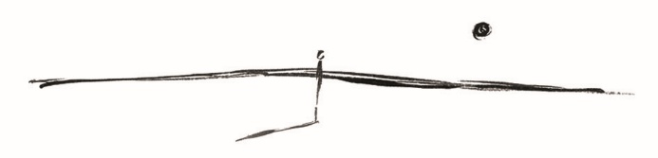

Ordering

Order in multipliers of six bottles, with minimum order for six bottles (can be mixed).

Please remember to add price of delivery to cost of wine when making payment.

The wine will be couriered to you on confirmation of payment.

Payment by cheque or EFT - see details below

Freight:
Region | Delivery per six pack/dozen | Region | Delivery per six pack/dozen
Melbourne Metro | $8 | Perth | $25
Sydney Metro | $15 | Adelaide Metro | $15
Queensland | $19

Cheques to Wanderer Wines, PO Box 233 Gembrook 3783 Vic

Electronic Funds Transfer:

Commonwealth Bank
Acct. Name: Wanderer Wines
BSB: 063 842
Acct. Number: 1023 5516

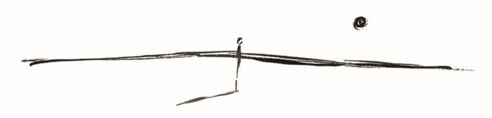

Please return to andrew@wandererwines.com
Order Form (min. order 1 six pack, unless otherwise stated) | Single | Qty. Ordered | $Cost
The Wanderer Macclesfield Yarra Valley Chardonnay 2024 | $40
Please order in multipliers of 6 bottles.
 | Sub total
 | Freight
 | TOTAL $

Name:

Delivery Address:

Delivery Instructions (ie. If Not Home):

Phone No :

